How to Prepare for Adulthood with Sheffield MENCAP
Generated by AI. Make sure to check for accuracy.
Meeting notes:

- Overview of Sheffield Mencap and Gateway: Evie Lord and Kate Brockley from Sheffield Mencap and Gateway provided an introduction to their independent charity, clarifying their distinction from the national Mencap, and outlined their vision and history supporting people with learning disabilities and their carers in Sheffield.
  - Charity Independence and Vision: Evie Lord explained that Sheffield Mencap and Gateway is an independent charity, separate from the national Mencap, though they share the name and collaborate at times. Their vision is to ensure all people with learning disabilities and their carers in Sheffield are valued, included, and respected.
  - Historical Background: The organisation was founded in 1951 by parents and carers of individuals with learning disabilities, initially to provide a place for their children to enjoy and develop, and has since evolved to offer a wide range of services.
  - Membership and Scope: Currently, Sheffield Mencap and Gateway supports over 700 members across Sheffield, providing lifelong support from early childhood through to end of life, including support for carers.

  - 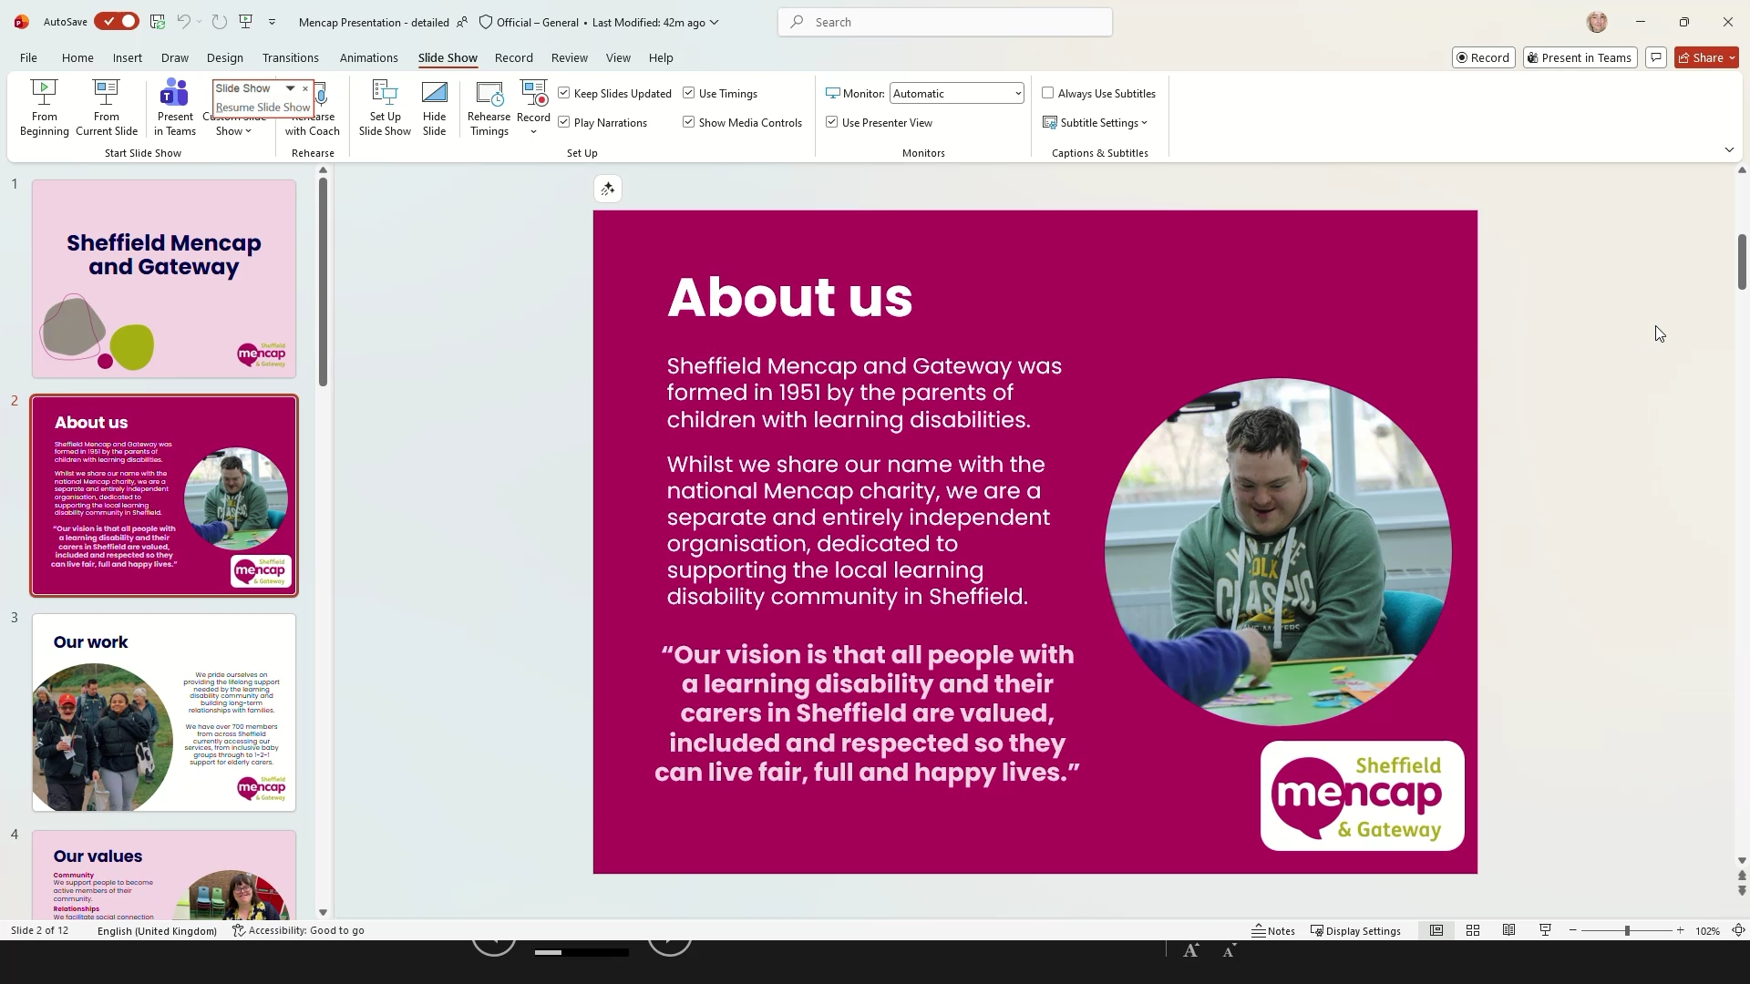

- Core Values and Service Structure: Evie Lord described the five core values guiding all Mencap services—community, relationships, independence, confidence, and wellbeing—and outlined the broad range of services offered to children, adults, and carers.
  - Core Values: The five core values—community, relationships, independence, confidence, and wellbeing—are embedded in all activities and are used to assess and encourage individual development.
  - Service Range: Services are not limited to day provision but include children’s activities, adult day services, evening and weekend groups, health support, and dedicated carer support, reflecting a holistic approach to supporting individuals and their families.
  - 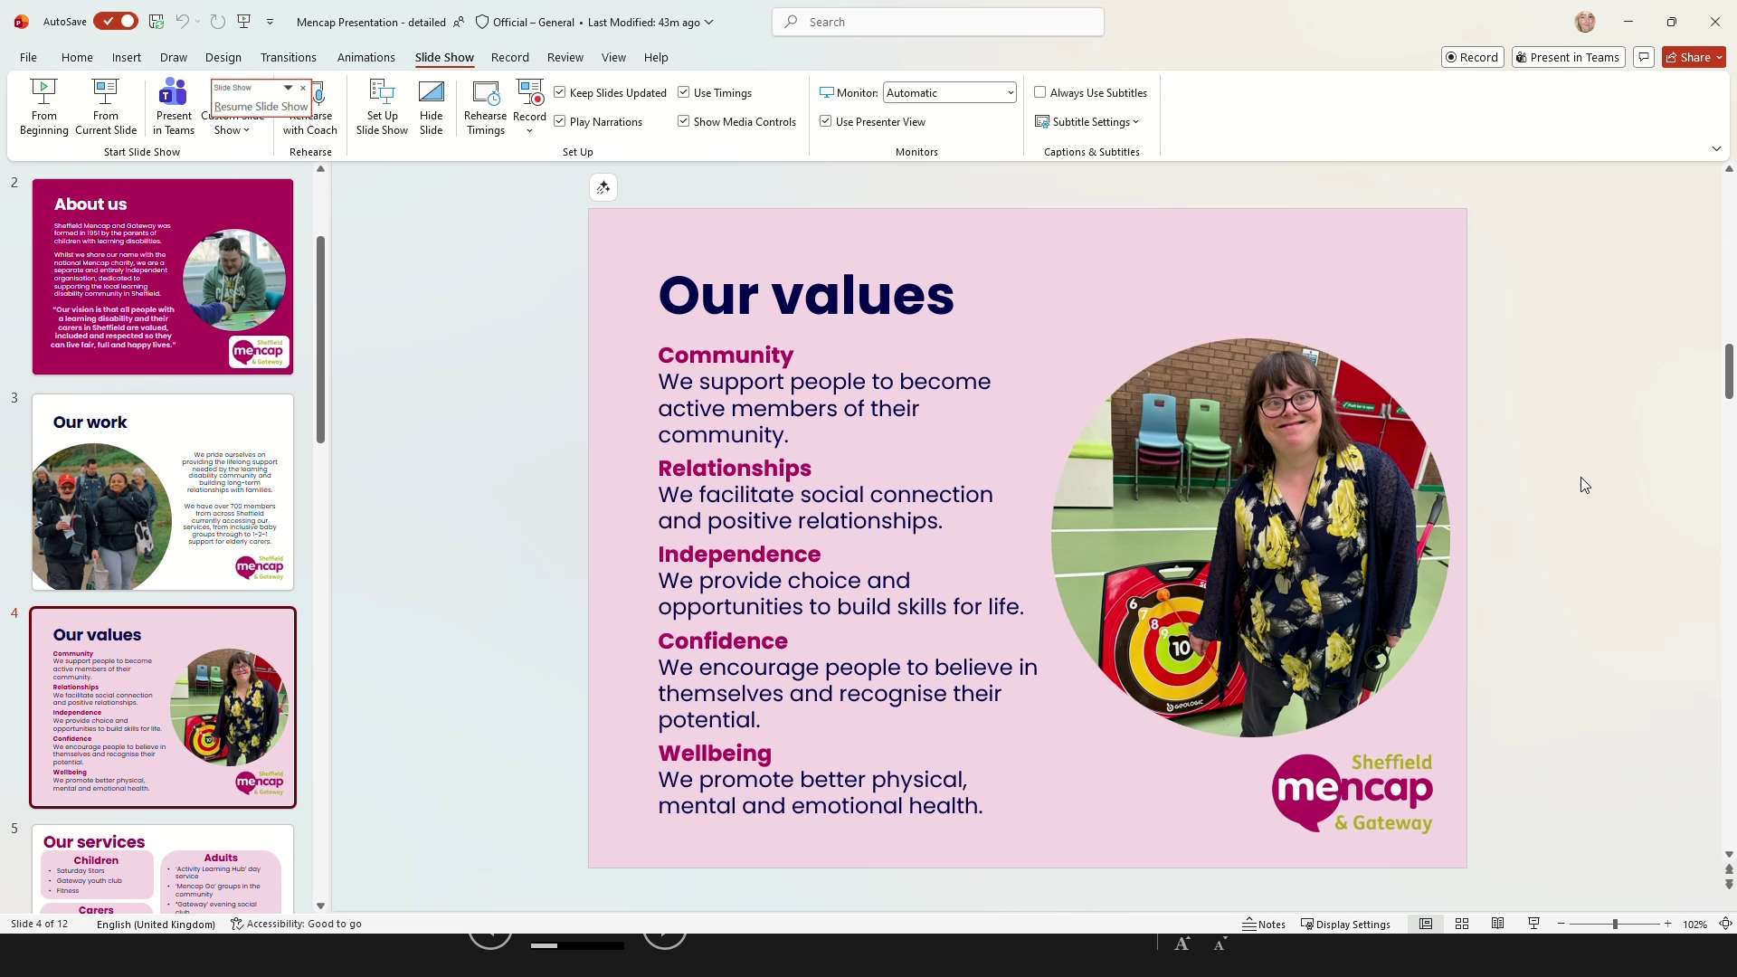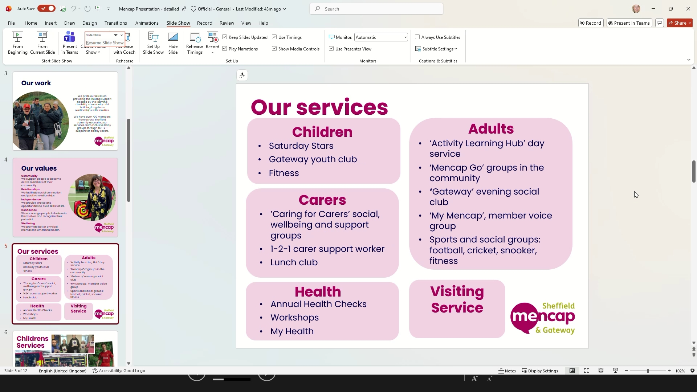
- Children’s Services and Short Breaks: Evie Lord detailed the children’s services, including fitness groups, youth clubs, drama, sports, creative sessions, and council-funded short breaks, with flexible payment options and support for families facing financial difficulties.
  - Weekly Children’s Activities: Children’s services include Thursday fitness groups, youth clubs, and Saturday sessions with drama, sports, and creative activities, catering to ages 5–17 and designed to build independence and social skills.
  - Short Breaks Provision: Short breaks (SNPs) are offered on Saturday afternoons during term time and in the holidays, funded by the council through direct payments, providing respite for families and opportunities for children to engage in structured activities.
  - Financial Accessibility: Sessions are self-funded at £4 per session, paid monthly, with flexibility for families experiencing financial hardship to ensure all children can access services.
  - 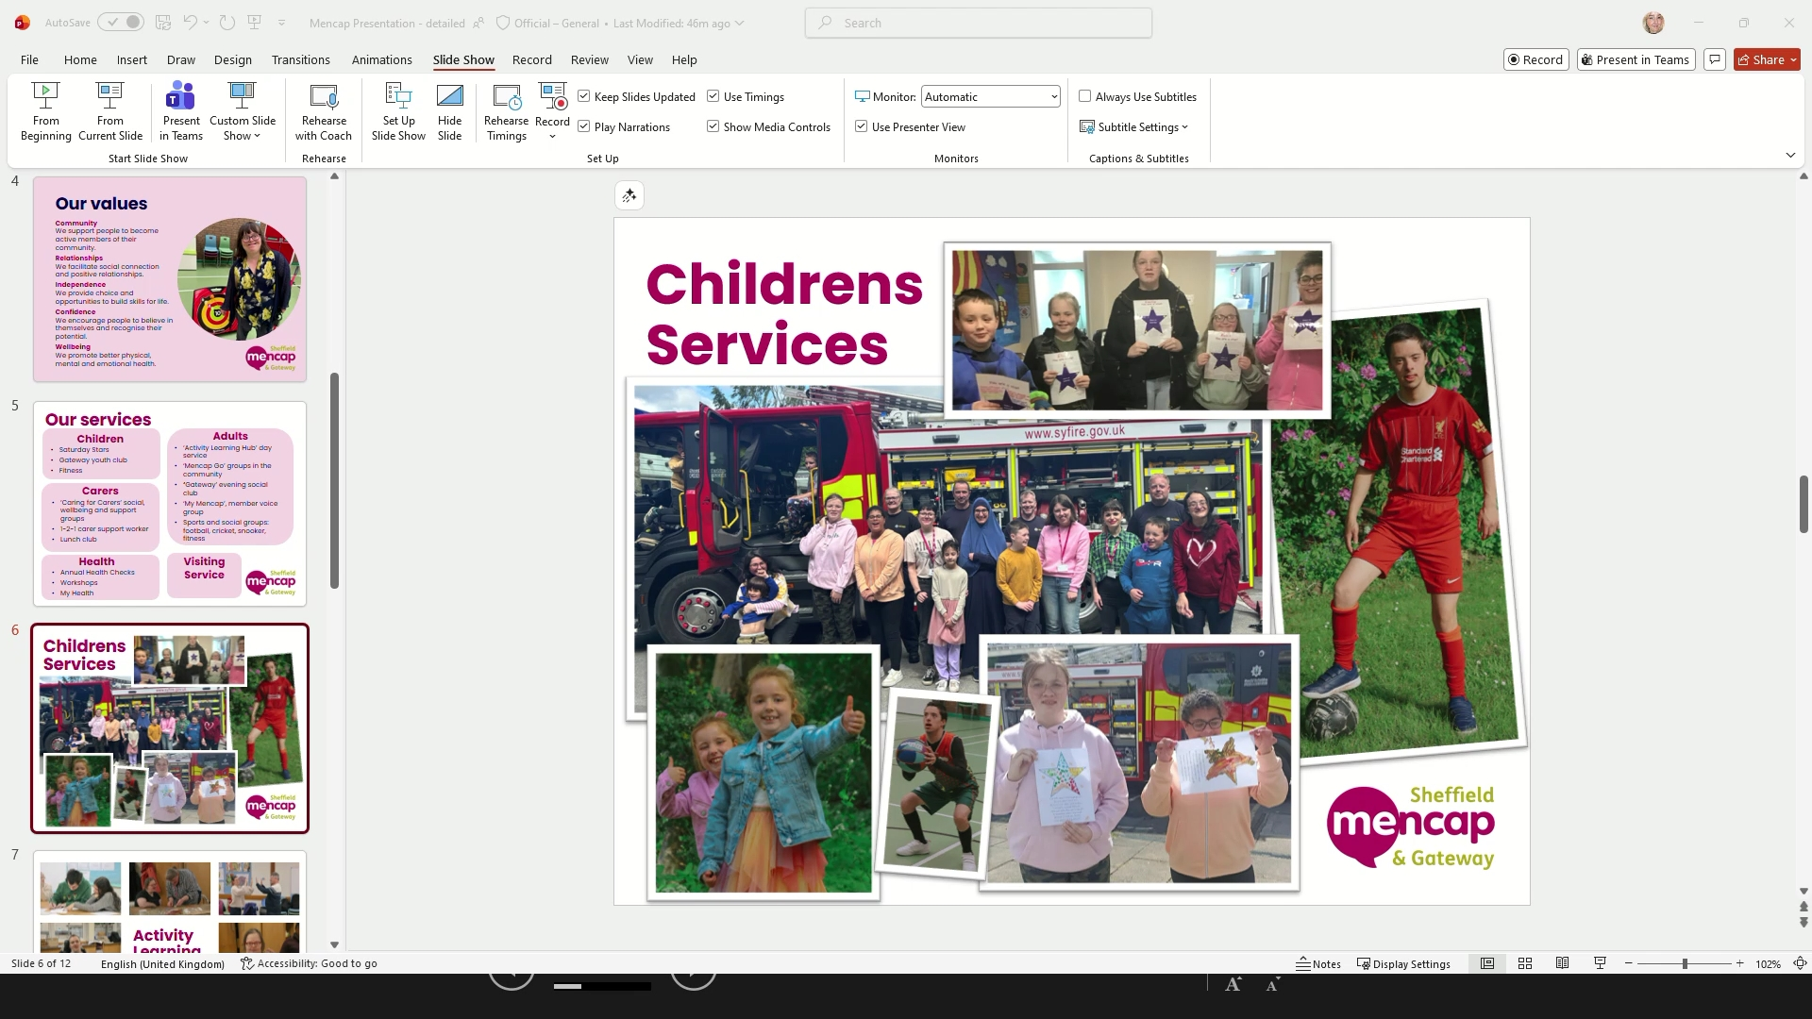
- Activity Learning Hub and Day Services for Adults: Evie Lord and Kate Brockley described the Activity Learning Hub, a member-led day service for adults, offering a variety of skill-building groups, qualification opportunities, and social activities, with funding through adult social care packages.
  - Daily Group Activities: The Activity Learning Hub operates Monday to Friday, with each day offering different groups such as art, performing arts, sports, and cooking, allowing members to choose activities based on their interests.
  - Member-Led Learning and Qualifications: Group leaders consult with members to tailor activities and, where possible, support them in working towards recognised qualifications, fostering engagement and personal development.
  - Assessment and Progress Tracking: Members are assessed each term against the core values, with progress tracked in areas such as relationships and confidence, ensuring support is tailored to individual needs.
  - Funding and Attendance Patterns: Attendance is typically two to four days per week, funded through direct payments as part of adult social care packages, with more qualification-focused activities earlier in the week and relaxed sessions later.
  - Summer Sessions and Community Integration: During summer, the Hub offers trips and travel training, encouraging independence and community participation, with options for both on-site and off-site activities.
  - 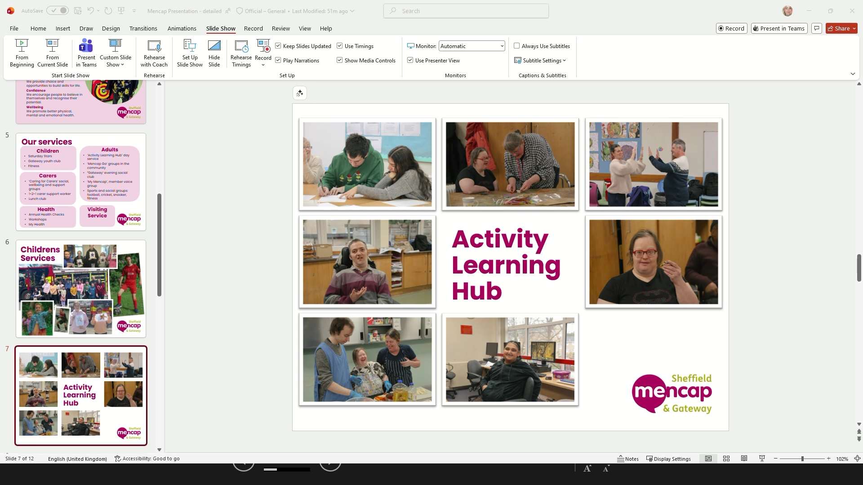
- Evening and Weekend Activities: Evie Lord outlined the Mencap Go programme, which includes evening and weekend social, sports, and special interest groups for adults, with flexible, pay-as-you-go attendance and opportunities for community engagement.
  - Gateway Social Groups: Monday to Wednesday evenings feature Gateway social groups with themed activities such as games, bingo, karaoke, and baking, fostering independence and social skills in a relaxed environment.
  - Special Interest and Sports Groups: Additional groups include a Saturday bowling group, a monthly walking group, and the Liberated Ladies social group, as well as sports sessions like cricket and fitness, all designed to suit varying interests and abilities.
  - Support and Accessibility: While one-to-one support is not provided by staff for large groups, participants can bring their own support workers or PAs, and the team can provide further details on session logistics if needed.
  - 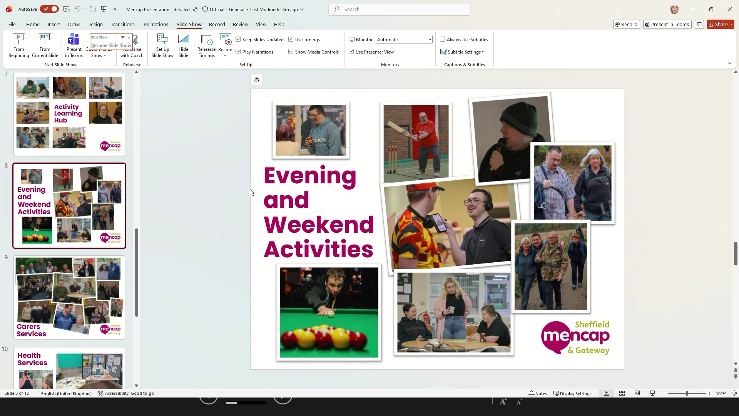
- Carer Support Services: Evie Lord described the comprehensive carer support services, including weekly groups, workshops, wellbeing sessions, and one-to-one support, available to all carers regardless of whether their family member attends Mencap services.
  - Weekly Carer Groups: Regular groups include a free parent and toddler group, a Wednesday carers group for peer support, and a Thursday evening group with guest speakers and workshops on topics like wills, trusts, and SEND support.
  - Wellbeing and Inclusive Activities: Wellbeing sessions such as inclusive yoga are offered, providing carers with opportunities to relax while their children are safely engaged in activities on site.
  - One-to-One and Ongoing Support: Drop-in support is available on Saturdays, and more complex or ongoing cases are managed by a dedicated staff member, ensuring tailored assistance for carers’ individual needs.
  - Inclusive Family Events: Seasonal events and get-togethers are organised for whole families, fostering an inclusive and supportive community environment.
  - 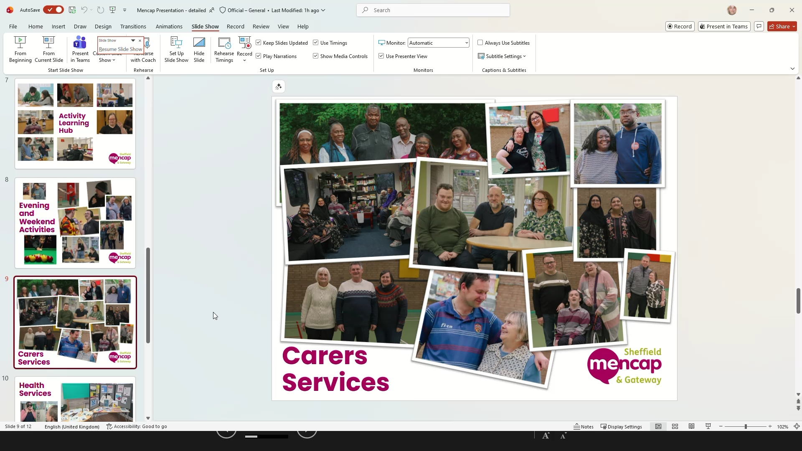
- Health Services and Annual Health Checks: Kate Brockley explained the health services available, including support with annual health checks for people with learning disabilities, healthy lifestyle courses, and resources for dental hygiene, with guidance on eligibility and access.
  - Annual Health Checks: Individuals with learning disabilities aged 14 and over are entitled to annual health checks through their GP, which include comprehensive physical assessments and medication reviews to address health inequalities.
  - Eligibility and Register Guidance: To access annual health checks, individuals must be on the learning disability register; those with autism alone are not eligible, and diagnosis typically occurs before age 18, though late diagnosis is possible.
  - Healthy Eating and Lifestyle Course: A popular eight-week healthy eating and lifestyle course is offered, using accessible materials and practical demonstrations to educate about nutrition, cholesterol, and healthy habits.
  - Dental Hygiene Resources: Resources and videos are available to support young people in understanding dental hygiene and what to expect at dental appointments, with easy-read materials and visual aids provided on request.
  - 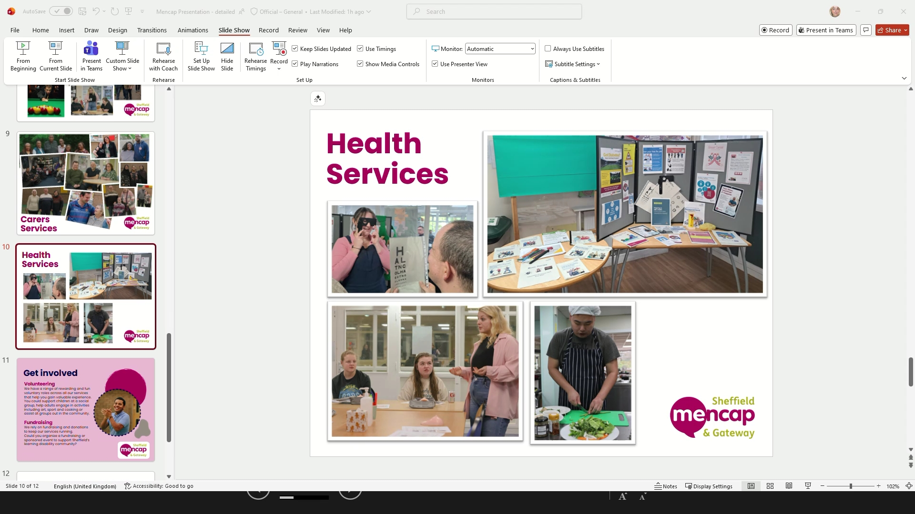
- Volunteering and Fundraising Opportunities: Evie Lord highlighted the importance of volunteers and fundraising for Sheffield Mencap and Gateway, inviting attendees to get involved in supporting services through voluntary roles or organising fundraising events.
  - Volunteer Roles: Volunteers are integral to all services, supporting activities for children and adults, and those interested can get involved in various roles to gain experience and contribute to the community.
  - Fundraising Initiatives: As an independent charity, Mencap relies on fundraising and donations, organising events such as summer days to help fund services and maintain financial accessibility for members.
  - 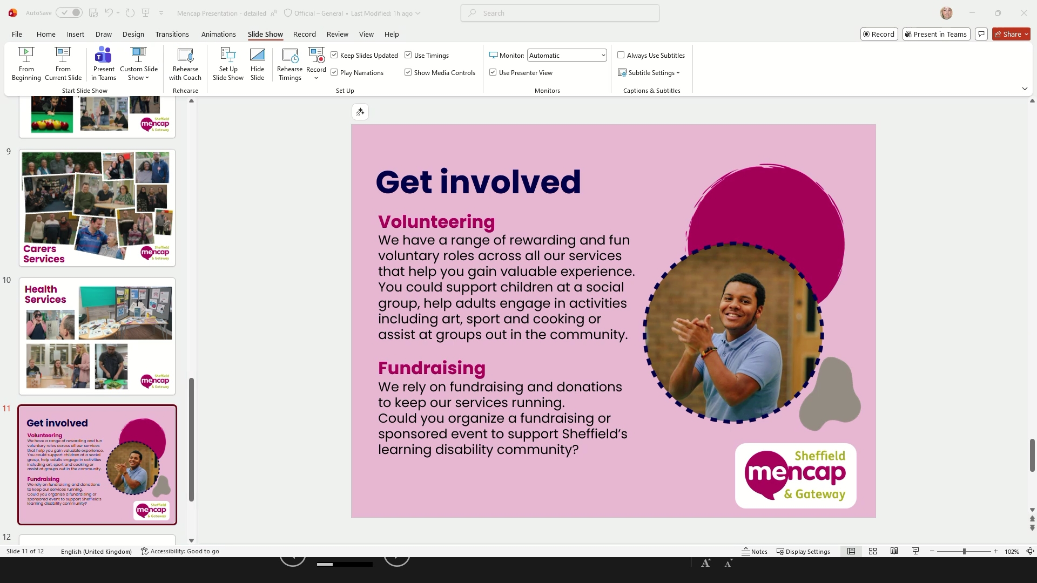
- Accessing Services and Application Process: Evie Lord and Kate Brockley explained the process for accessing Mencap services, including application forms, free trial sessions, and support with finding suitable activities or alternative providers if needed.
  - Application and Trial Sessions: Interested individuals can apply via forms available on the website or by email, and are offered a free trial session to ensure suitability before committing to regular attendance.
  - Support with Finding Alternatives: If Mencap services are not suitable, staff are happy to signpost to other organisations or activities that better match the individual's interests and needs.
  - 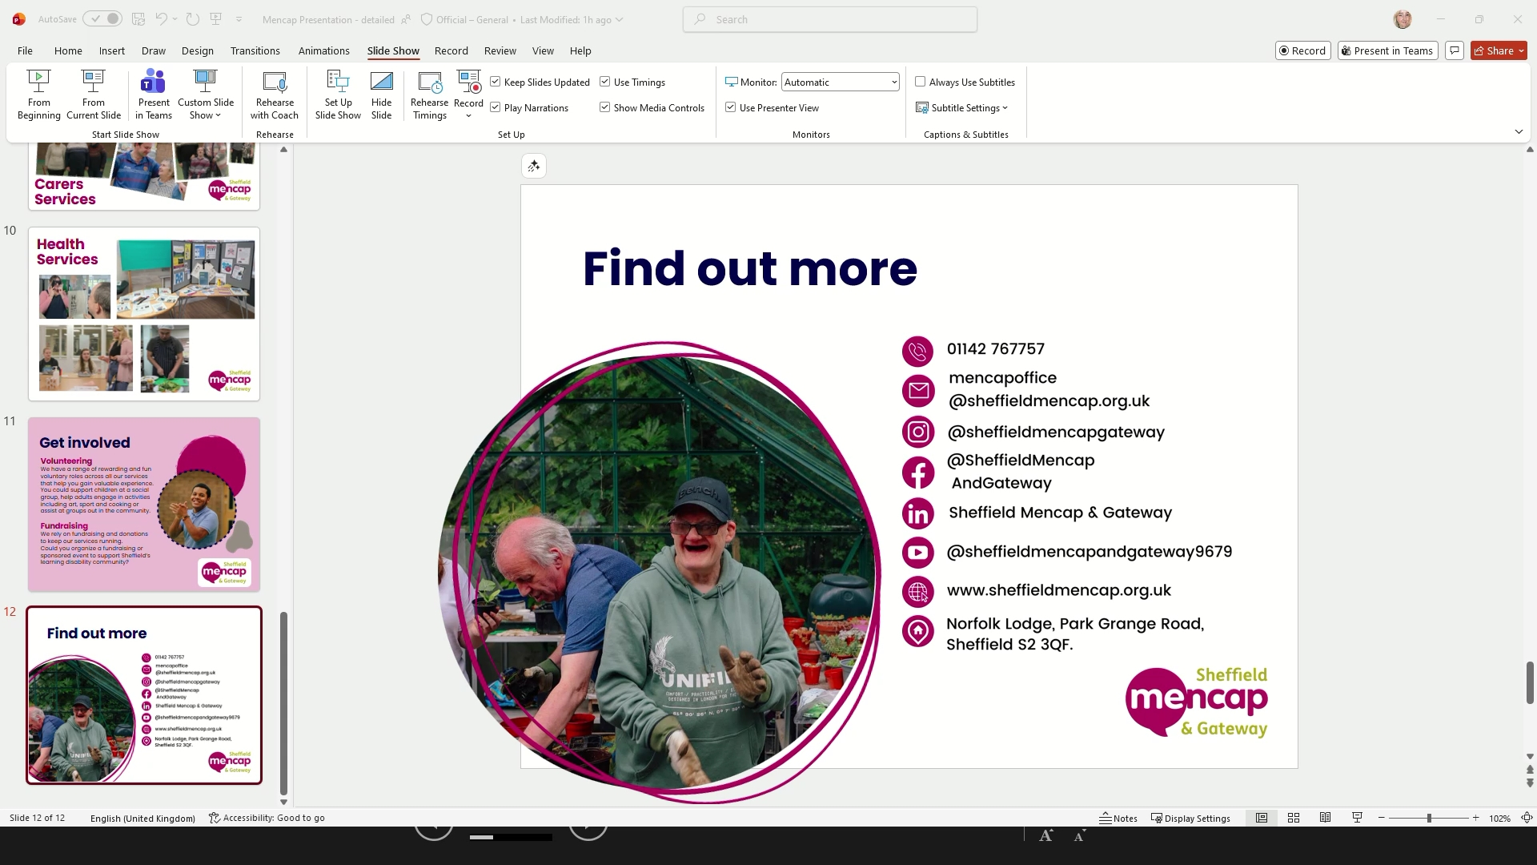
- Respite and Adult Social Care Options: Evie Lord clarified that while Sheffield Mencap offers short breaks for children, there are currently no adult respite options, but the team can assist with signposting to other services and support navigating adult social care.
  - Children’s Versus Adult Respite: Short breaks (SNPs) are available for children, but there are no equivalent respite options for adults; families seeking adult respite are encouraged to contact Mencap for signposting to other providers.
  - Support with Social Care Navigation: Maria and the Mencap team offer support and guidance to families navigating the complexities of adult social care services in Sheffield.
- Collaboration with Opportunity Sheffield and Employment Pathways: Craig from Opportunity Sheffield discussed potential collaboration with Mencap to create a referral pathway for supported employment, with Evie Lord confirming willingness to connect and support members interested in work or volunteering.
  - Referral Pathway Discussion: Craig enquired about establishing a referral pathway between Opportunity Sheffield and Mencap, and Evie Lord agreed to arrange a meeting to discuss collaboration and support for members interested in employment.
  - Employment and Volunteering Support: Mencap supports members in exploring employment and volunteering, with some members already volunteering or working, and referrals to Opportunity Sheffield are made where appropriate.
- Success Stories and Case Studies: Caitlin and Craig asked about success stories, and Evie Lord shared examples of members achieving personal goals, such as joining national sports teams and gaining employment, highlighting the positive outcomes of Mencap’s programmes.
  - Sports Achievement: A member who regularly attends Mencap services was selected to play for the National Mencap and England football team, demonstrating the opportunities for skill development and recognition.
  - Employment Success: Another member, identified by Craig, successfully gained employment after participating in Mencap programmes and volunteering, illustrating the impact of collaborative support.
- Guidance on Post-16 Education and Local Offer Resources: Maria provided information about the post-16 guide for young people in Sheffield, detailing education options at level 2 and below, and encouraged attendees to access resources and recordings on the Local Offer website.
  - Post-16 Guide Overview: The guide covers education pathways for young people not following the traditional GCSE route, including specialist and mainstream options, and is organised by career path with entry requirements and career information.
  - Access to Resources: All event recordings, resources, and the post-16 guide are available on the Local Offer website, with links shared for further exploration and feedback.
  - 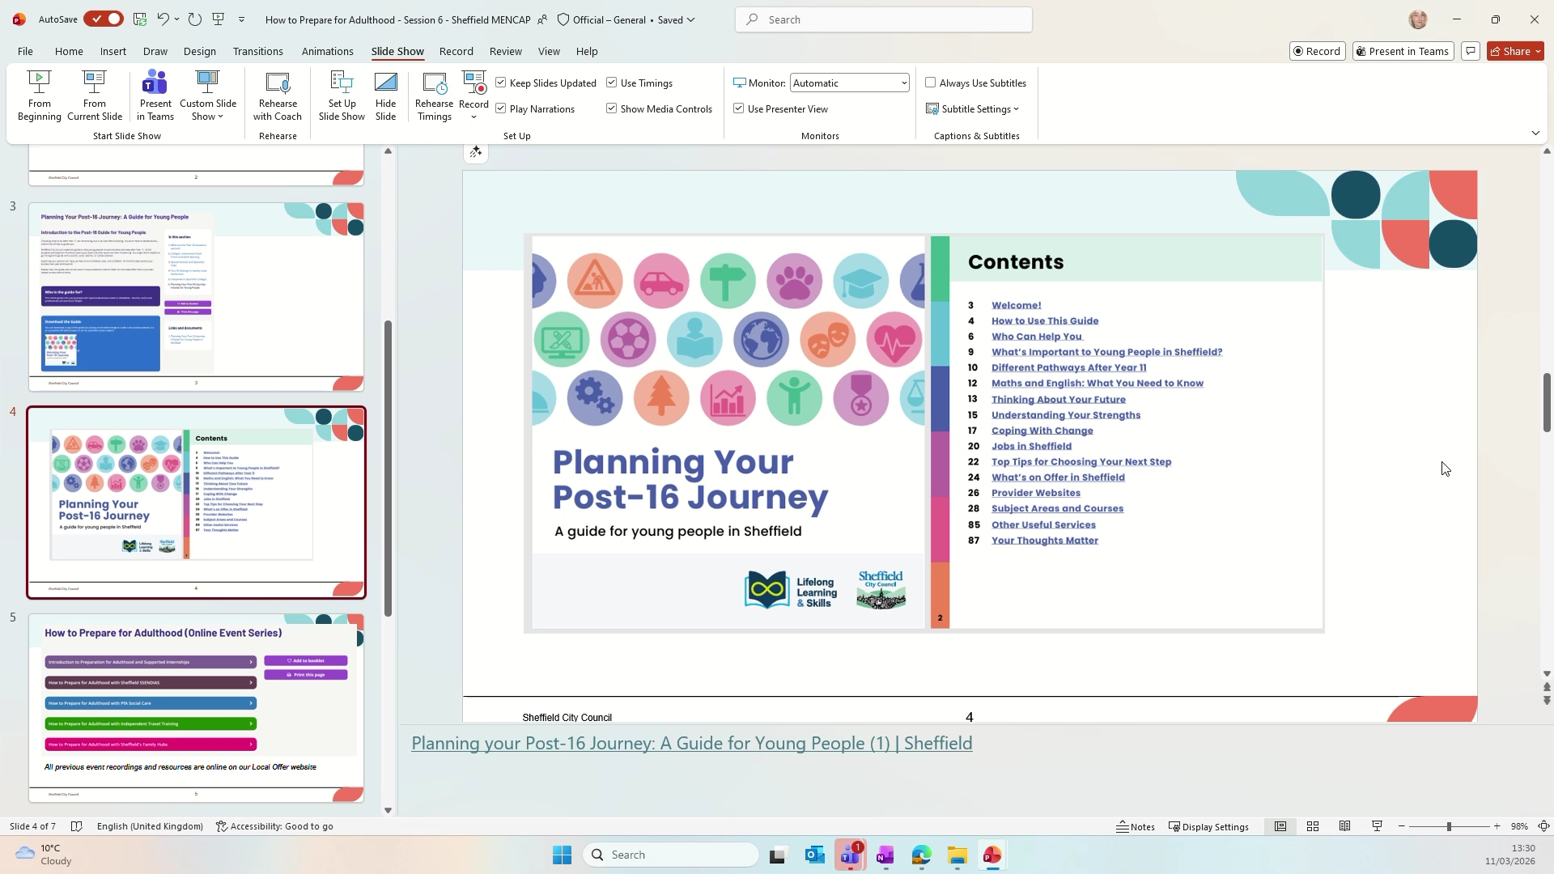
Follow-up tasks:
- Dental Hygiene Resources for Young People with Learning Disabilities: Send resources (including videos and easy read materials) to Maria to support young people with the significance of maintaining good dental hygiene, for further distribution. (Evie Lord)
- Distribution of Dental Hygiene Resources: Share the dental hygiene resources received from Evie Lord with all attendees and those who signed up for the session. (Maria)
- Signposting for Adult Weekend Respite Options: Assist in finding and sending information about available adult weekend respite options for a young person about to turn 18 with Down syndrome and severe learning difficulties, following the enquiry in the meeting. (Evie Lord)
- Referral Pathway Collaboration with Opportunity Sheffield: Arrange a meeting with Craig to discuss creating a referral pathway between Sheffield Mencap and Opportunity Sheffield for supporting people into work. (Evie Lord, Kate Brockley)
- Sharing Case Studies of Service User Success: Share any written or video case studies of service user success stories with Maria for wider dissemination. (Evie Lord, Kate Brockley)

