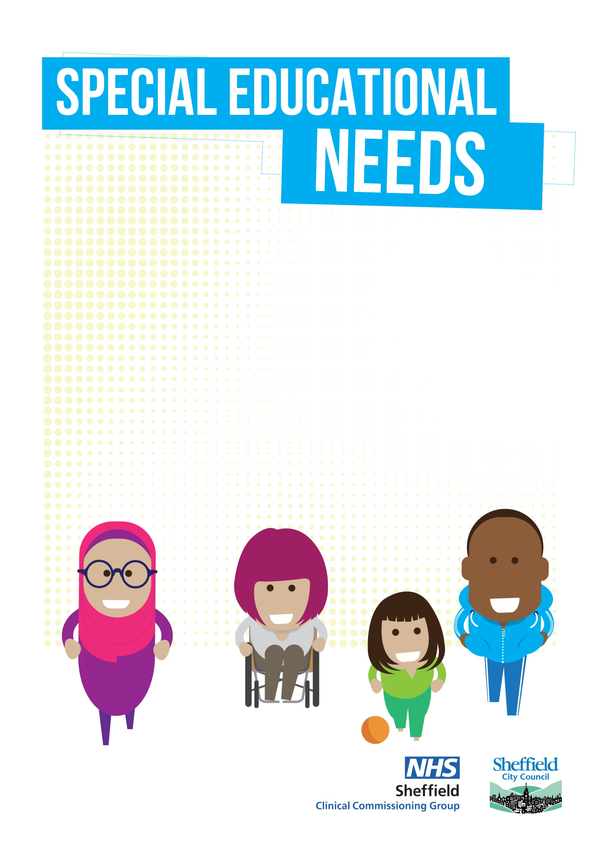

Autism Social Communication Team
Graduated Response
5-25
Universal Targeted – See below

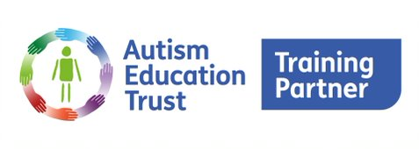
To ensure we safeguard our capacity for the children most in need of support, we require our pupils to have a diagnosis of autism OR (from FS2 onwards) be displaying significant social communication differences to a level where they have formally been accepted onto on the Neurodisability – Autism Assessment, pathway. In addition and in terms of presentation at school, they would have been levelled at 4 (refer to Universal Offer) or higher on Early Years or Sheffield Support Grid and we would prioritise those for whom a mainstream school place, is at risk.

NO
YES
Please note referrals will only be accepted from Settings SENCo’s with Parental Agreement
NO
NO
All settings are entitled to access our Universal Offer, designed to support with embedding QFT for all.
This offer includes workshops, relevant documents, and training videos.
YES
Can you provide predicted outcomes for the pupil which will be agreed and recorded on the referral to ensure our team, build upon what is currently in place in line with the Graduated Response.

Can you provide evidence of recent reviewed SEN support?
Please contact your Link Teacher to arrange a structured conversation around a plan of support.
We wish the conversation to be based around what you hope to achieve (Outcomes)
Following the conversation, you will be asked to complete a streamlined referral form (and a short questionnaire if the child is new to us) with the link teacher’s details completed beforehand to ensure processing by our business support team.
The pupil will be opened onto our caseload, whilst the support is in place.
Outcomes and rating scale will be completed and revisited after support from the ASC Team to measure impact.

YES

