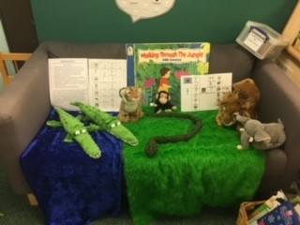
July 2026 Training Sessions at
Sheffield Early Years Language Centre
(previously known as Ucan)
Located in Primrose Family Hub,
Creswick Street, Sheffield S6 2TN

Sheffield Early Years Language Centre (SEYLC) provides a short term intensive speech and language therapy intervention to children ages 3-5, who are being assessed for a possible diagnosis of Developmental Language Disorder. This is provided by Sheffield Speech and Language Therapy and 0-5 SEND Support Service.
The Centre holds training sessions twice yearly for staff from early years settings and schools to attend. These sessions provide opportunities for you to:
- hear about the strategies, approaches and activities used at the language centre to support children with speech and language needs
- see the provision, range of visual support materials and resources, and hear from language centre staff how these are used in their work with the children
- receive examples of visual support materials and further resources for you to take back to your setting
The strategies, provision and resources you will see when you attend can also be appropriate to use with other children who have a wide range of Speech Language and Communication Needs, as well as those for whom English is an additional language.
The summer term training sessions will be held on:
- Monday 13 July - 1:00 – 3:30pm
- Tuesday 14th July - 9:00-11:30am

This year we have additional sessions on how to support children’s speech, language and communication development, with a greater focus on:

- Using visual resources, core vocabulary and communication books
Tuesday 14th July – 3.30 -4.30pm
Wednesday 15th July – 9.30 – 10.30am

- Planning and delivering language activities
Wednesday 15th July – 1.30 – 2.30pm

If you would like to book a place on a training session, please contact:

Sally Rowland – 07989164075 or email Sally.rowland@sheffield.gov.uk

