New Childcare Digital Tool Visual
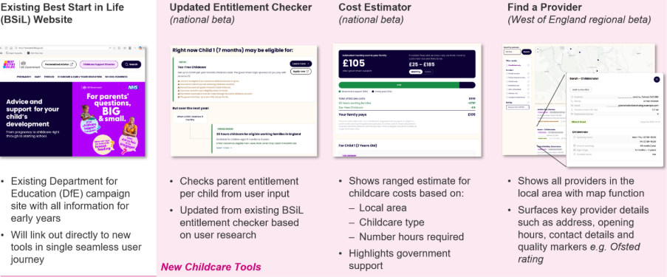

FAQs
What data are you using?
Data used in “Find a Provider” is collected from the Ofsted Early Years Register, School Census and Get Information About Schools, and enriched with data from the LA FIS website.
We are working with LA/FIS teams and Childminder Agencies operating in the beta region to ensure data it is kept up to date.
How are inspection outcomes displayed for new Ofsted ratings and childminders registered with Childminder Agencies?
We have worked with Ofsted to ensure that the new rating system is appropriately represented in “Find a Provider” with an at-a-glance summary available in the search results, alongside additional detail available when clicked though for individual providers.
We are also working directly with Childminder Agencies to agree display of their inspection outcomes in line with Ofsted outcomes.
I have feedback to share
Great! We look forward to receiving it. A ‘beta’ enables families to start using the tools while we continue to take on feedback and make improvements. There will be this feedback form available at the top of the new Best Start in Life tool pages.
When will “Find a Provider” be expanding nationally?
We are working towards a national expansion by the end of the year and will be in touch with LAs with additional details as we plan this rollout.
How are costs estimated?
The “Cost Estimator” uses data from DfE’s 2025 Survey of Childcare and Early Years Providers (SCEYP), and is designed to be consistent with the data surfaced by DfE in Section 8 of the Childcare and early years provider survey statistics. This means that we report averages using the same DfE weighting methodology, as outlined in the DfE documentation Methodologies of the Childcare and early years provider survey statistics. Also, in line with DfE’s reporting approach, we consider averages based on fewer than 30 responses to be unreliable and hence we do not surface these, falling back to a broader geographical estimate with a greater number of responses.
The estimator assumes full utilisation of the government support e.g. using 570/1,140 funded hours a year and 85% UC reimbursement of outstanding childcare costs, and does not currently estimate costs for additional extras, such as consumables and food, and this is caveated throughout the tool.

