**Special School Information for Parent / Carer Visits**

For children and young people who require more support and intervention than a mainstream school or IR is able to provide, it may be appropriate to consider a placement in a special school. These schools generally have teachers and support staff who are trained and experienced in working with children with the most complex special educational needs, with smaller class sizes and high adult: pupil ratios. The curriculum may be much more tailored toward achieving life skills and independence, rather than seeking academic outcomes. Special school places are for children and young people with an EHC Plan for whom mainstream school is not a possibility.

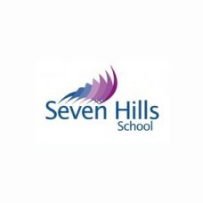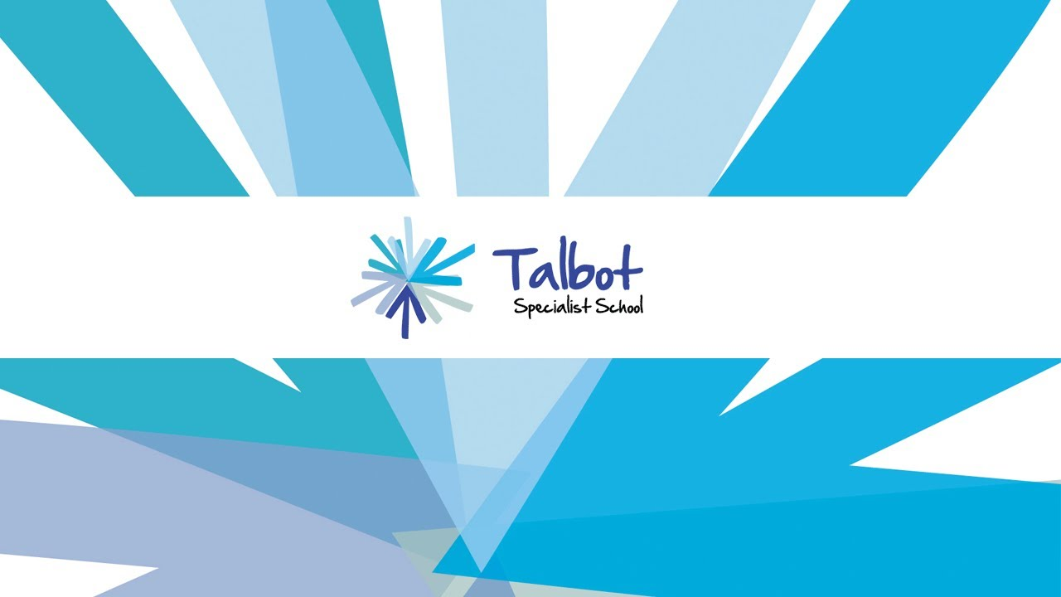

**Seven Hills School**Granville Road, S2 2RJ  
0114 274 3560   
www.sevenhillslearning.co.uk

**Talbot School**

Lees Hall Road, S8 9JP  
0114 250 7394  
www.talbotlearningcommunity.org.uk

Talbot provides education for young people aged 11-19 with a wide range of needs including Severe and Complex learning difficulties, Autistic Spectrum Disorders and Profound and Multiple Learning Difficulties. Talbot offers an aspirational, personalised and multi-sensory curriculum designed to ensure that students are successful and enjoy their learning.

Talbot have sent email to all primary schools inviting parents / carers to two visit dates. Parents to phone and book their place.

Seven Hills School is an 11-19yr secondary school for students with severe learning difficulties and complex needs. The school is an inspirational community, which nurtures talents, shares learning and celebrates life. Students are challenged to achieve their full potential; teaching is designed to inspire and create activity, curiosity and engagement.

Call school to book a prospective parents / carer visit.

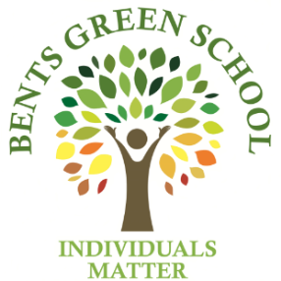

Bents Green provides education for young people 11-19 with Autistic Spectrum Conditions and Communication and Interaction difficulties. As well as the main special school site, Bents Green has a ‘hub’ within Westfield mainstream secondary school for pupils who have the ability to access part of the mainstream curriculum, whilst requiring the specialist support from Bents Green staff and resources.

Dates for prospective parents visit on website – call school to make an appointment.

**Bents Green School**  
Ringinglow Road, S11 7TB  
0114 2353545   
www.bentsgreenschool.co.uk

**Discovery Academy**Park Grange Road, S2 3QF  
0114 479 8000   
www.discoveryacademy@nexusmat.org



Discovery Academy is a Specialist Academy for students aged between 7 to 16 years who either have a diagnosis of autism, or be on the diagnostic pathway. They may also have related Social, Emotional and Mental Health (SEMH) Needs. Some children may also have specific learning difficulties (SPLD) which results in them working below age-related expectations in some subjects.

Please call school to make an appointment for a visit.

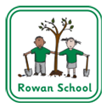

Mossbrook is a maintained primary special school in Sheffield where staff have the knowledge and skills to meet the needs of pupils aged four to eleven years old. Our pupils have Autism and associated communication, learning and behavioural needs, although we are not a school for children whose primary needs are social, emotional and mental health. The school is located on two sites.

Please call the school office to make an appointment to visit school as a prospective parent / carer.

**Mossbrook School**  
Bochum Parkway, S8 8JR  
0114 2372768  
www.mossbrook.sheffield.sch.uk

Rowan School provides education for young people 4-11 with a medical diagnosis Autistic Spectrum Conditions (ASD) and related Speech, Language and Communication (SLCD) difficulties. Sensory impairment or emotional behavioural difficulties may compound difficulties but will not be the primary area of need. The school admits pupils with severe or complex learning difficulties significantly below normally expected levels.

Please fill in the online form on our website to make an appointment to visit school as a prospective parent / carer.

**Rowan School**  
4 Durvale Court, S17 3PT  
0114 2350479  
www.rowanschool.co.uk

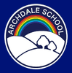

**Archdale School**  
Archdale Road, S2 1PL  
0114 2726165  
www.archdale.sheffield.sch.uk

**Woolley Wood School** Chaucer Road S2 1PL  
0114 2327160  
www.woolleywood.sheffield.sch.uk

Woolley Wood School is a small primary school, including nursery for children with severe and complex learning difficulties and disabilities. Many of our pupils have additional needs in the areas of mobility and physical development, vision, hearing and communication, including autism.

Please call the school to make an appointment to visit.

Archdale School caters for children between the ages of three and eleven years with profound and multiple learning difficulties, severe learning difficulties, complex medical needs and autism.

Please fill in the online form on our website to make an appointment to visit school as a prospective parent / carer.

**Holgate Meadows School and Heritage Park School**  
Lindsay Road, S5 7WE Norfolk Park Road, S2 2RU  
0114 2456305 0114 2796850  
[www.trustschoolstrust.org](http://www.trustschoolstrust.org) We are special schools for pupils aged 6 to 16 years with social, emotional and mental health needs. All of our pupils have Education, Health and Care Plans which identify social, emotional and mental health needs as a primary need. Both schools follow their own operational procedures but share the same core values and strategic vision. Please contact the school for further information.